Faculty Achievements for Annual Report (Session 2025–2026)
Indian Institute of Information Technology, Sonepat
Section 1: Basic Information
Full Name: Dr. Mukesh Mann
Designation: Assistant Professor
Department / Discipline: CSE, IT (Deputed)
Email ID: mukesh.maan@iiitsonepat.ac.in
Phone Number: 9873106374

Message from the Desk of Faculty Incharge
About the Department
We are thrilled to welcome you to the Department of Information Technology at IIIT Sonepat. Being a part of this department is not just about academic growth—it’s about being at the forefront of technology, innovation, and shaping the future of IT. Our department stands proudly on the foundation of excellence, with a strong focus on nurturing the minds that will define tomorrow’s tech landscape. At IIIT Sonepat, we don’t just teach technology; we push the boundaries of what’s possible. Through groundbreaking interdisciplinary collaborations, our faculty, students, and researchers dive deep into high-end research, solving some of the most pressing challenges of the digital age. We strive for innovation that does not just keep up with the times but leads the way. As an institution, we encourage an environment where critical thinking, creativity, and problem-solving are not just ideals, but the very principles we live by. We believe that in the ever-evolving field of IT, one must constantly adapt, learn, and grow. With access to Excellent labs facilities equipped with modern Software tools and technology, our students are equipped to meet the needs of an increasingly digital world. Whether it’s Artificial Intelligence, Cybersecurity, Data Science, Cloud Computing, or IoT, we aim to produce not just students, but innovators who can turn ideas into reality. Our B.Tech (IT) program offers a well-rounded curriculum designed to create a balance between technical knowledge, hands-on experience, and real-world applications. The program is structured to allow students to thrive not just in coding, but also in creative problem-solving, data-driven decision-making, and designing the technologies that will change the world. At IIIT Sonepat, we encourage our students to challenge themselves, collaborate, and above all, think differently. As technology continues to reshape every aspect of our lives, we are committed to making sure our graduates don’t just keep pace—they set the pace. Welcome to a future of endless possibilities. Together, let’s innovate and redefine what’s next in IT.
Dr. Mukesh Mann
Faculty Incharge , Dept of IT

First Story You have to write is
Know Indian IT Scientist Born in March

Here you have to make A one page story of him and his contributions.

Publications

Dr. Mukeh Mann
1. M. Shahid, M. Mann, Advance Performance Enhancement Framework for Software Defined
Networking, In 2nd International Conference on Pioneering Developments in Computer Science
and Digital Technologies (IC2SDT2025), 4–6 December 2025, hosted by the Department of
Computer Science and Engineering, National Institute of Technology Delhi, https://doi.org/
10.1109/IC2SDT68218.2025.11383691.

2. N. Garg, S. Kumar, D. Singh, N. Kumar, M. Mann, Optical Character Recognition (OCR)
with Text Generation Using Tesseract and PDF Editing Web Application Using Flask, In Hybrid
Intelligence: Theories and Applications (HITA 2024), Lecture Notes in Networks and Systems,
vol 1467, Springer, Singapore, https://doi.org/10.1007/978-981-96-7753-5_44.

3. M. Mann, R. Jaglan, C. V. Reddy, R. P. Badoni, Blockchain-Driven Roundabout Production
Network: Ensuring Trust, Recognizability, and Transparency in the Agri-Food Supply Chain, In
Hybrid Intelligence: Theories and Applications (HITA 2024), Lecture Notes in Networks and
Systems, vol 1467, Springer, Singapore, https://doi.org/10.1007/978-981-96-7753-5_43.

4. M. Mann, C. V. Reddy, M. Zaid, R. P. Badoni, Improving Web Page Quality Through
Empirical Analysis of Web Metrics, In Hybrid Intelligence: Theories and Applications (HITA
2024), Lecture Notes in Networks and Systems, vol 1467, Springer, Singapore, https://doi.
org/10.1007/978-981-96-7753-5_12.

5. M. Shahid, M. Mann, Advance Performance Improvement Framework (APIF) for Software Defined Networking, In Second International Conference on Pioneering Developments in Computer Science & Digital Technologies (IC2SDT), Delhi, India, pp. 106–111, https://doi.org/10.1109/IC2SDT68218.2025.11383691.
6. M. Mann, R. P. Badoni, P. Narooka, et al., Spatiotemporal trust evaluation using a
neutrosophic model under sensor uncertainty, In Discover Computing, vol. 28, 249 (2025)(SCIE,
IF 2.5), https://doi.org/10.1007/s10791-025-09750-8.

7. V. R. Chaganti, M. Mann, R. P. Badoni, S. B. Mandyam, Advanced Computer Vision
Techniques for Football Match Analysis: Detection, Team Assignment, and Player Tracking,
In International Conference on Artificial Intelligence and Emerging Technologies (ICAIET),
Bhubaneswar, India, pp. 1–6, https://doi.org/10.1109/ICAIET65052.2025.11211437

8. M. Mann, A. Mishra, C. V. Reddy, R. P. Badoni, Optimizing Traffic Signal Control Using
Reinforcement Learning, In Soft Computing: Theories and Applications (SoCTA 2024), Lecture
Notes in Networks and Systems, vol 1344, Springer, Singapore, https://doi.org/10.1007/
978-981-96-5958-6_21.

Books / Book Chapters Published:
- A. Agrawal, S. Verma, A. K. Sharma, A. Kumar, M. Mann, P. Baniya, Security Challenges in Cloud-Based Watermarking, In Digital Watermarking in Cloud Environments For Copyright Protection, pp. 37–64, IGI Global Scientific Publishing, https://doi.org/10.4018/979-8-3373-3785-2.ch002.

Research Projects / Grants Received:
Dr. Mukesh Mann Received Haryana NTD Grant-25 of Rs 50000 from the Department of Science
and Technology, Haryana for National Technology Day.

Section 3: Professional Activities
Workshops / Conferences Attended:
Session Chair in 5th International Conference on Information Technology, InCITe-2026 is organized by Department of Information Technology, Amity School of Engineering & Technology, Amity University Uttar Pradesh, Noida on 26th – 27th February 2026.
Dr. Mukehs Mann attended 2026 India Association of Test Publishers (I-ATP) Conference on “Building India’s Future Together: The Next Frontier in Learning and Assessment

Student activities
Dept of IT Organized -- had the privilege of serving as the convener for Hackzilla 2025, held at IIIT Sonepat. This hackathon attracted over 1,100 participants, forming 492 teams. After a rigorous evaluation process, 31 teams were shortlisted for the offline rounds, representing institutions such as IIITs, NITS, IIITs.
The event culminated in the selection of the top three winning teams:
- 🥇 CrackNuts (IIIT Kottayam)
- 🥈 Kaleshi Coders (IIIT Sonepat)
- 🥉 Peaky Binders (IIIT Kottayam)
Hackzilla 2025 was a celebration of innovation, technical excellence, and collaboration. The event was made possible thanks to the generous support from our sponsors, including DST Haryana, Axis Finance, GeeksforGeeks, Unstop, Dot XYZ, and Hackr.io. Special thanks to the dedicated student coordinators and mentors for ensuring the event's success.
I served alongside my co-conveners, Dr. Rajiv Verma, Dr. Jitendra Samriya, Mohan Bansal, and SMIEEE, under the leadership of Prof. (Dr.) Manisha Sharma, Director, IIIT Sonepat.
New Initiatives
Initiating NCC at the Institute
As part of our continuous efforts to provide holistic development opportunities for our students, I successfully organized an initial meeting for starting the National Cadet Corps (NCC) at the institute. The meeting was conducted with NCC officers, and the discussions were fruitful, focusing on the benefits of NCC and how it aligns with our goals of fostering leadership, discipline, and national service among students. This marks an important step towards strengthening our extracurricular offerings and providing valuable life skills to our students.
Workshops / FDP / Conferences Organized:
- Organized “Hackzilla 2025”, a national-level 24-hour Hackathon at IIIT Sonepat, 28-29 May 2025.
Invited Talks / Guest Lectures Delivered:
ATAL Online 6 Days Faculty Development Programme 2025-26 organized by Jain university on Exploring the Foundations and Applications of Quantum Computing: Bridging Theory and Practice on September 2025 on topic Building Quantum Applications: Tools and Frameworks
Editorial / Reviewer Roles in Journals:
- Scientific Reports
- International Journal of Computational Intelligence Systems
- The Journal of Supercomputing
- Iran Journal of Computer Science
- Physica Scripta
- Int. J. of Electronic Security and Digital Forensics
Nominations-
Ex-Director, IIIT Sonepat nominate Dr. Mukesh Mann, Assistant Professor, Department of Computer Science and Engineering Nominated for One week Program on Nurturing Future Leadership Program under the Malaviya Mission Teacher Training initiative at Shiv Nadar University from April 22 to April 26, 2025

Section 4: Awards and Recognition
Events Conducted/Organized:

Participation in Cultural Activities:
1.
Participation in National Events:
Awards / Honors Received During the Session:
Doctoral Student of Dr. Mukesh Mann and Dr. Vinay Pathak Mr. Ashish Arya received best paper award titled - Qancient: A low- Depth Quantum dataset “in 13th IEEE Internationla Conference on Intelligent Systems and Embedded Design – 2025 organized by Dept of Computer Scinec and Engineering at National Institute of technology , Raipur

Any other significant Academic & Professional Achievement:

Section 5: Additional Contributions
Administrative Responsibilities:
- Faculty Incharge , Dept of IT
- Member BoG, IIIT Sonepat
- Purchase committee, IIIT Sonepat, Sonipat, Haryana
- Nodal Officer for Samarth Smart Portal, IIIT Sonepat, Sonipat, Haryana

Final Declaration
I confirm that the above information is correct and may be used in the Annual Report of IIIT Sonepat.

Mohan Bansal

Please find attached a few pictures from Hackzilla 2025 and other major events.

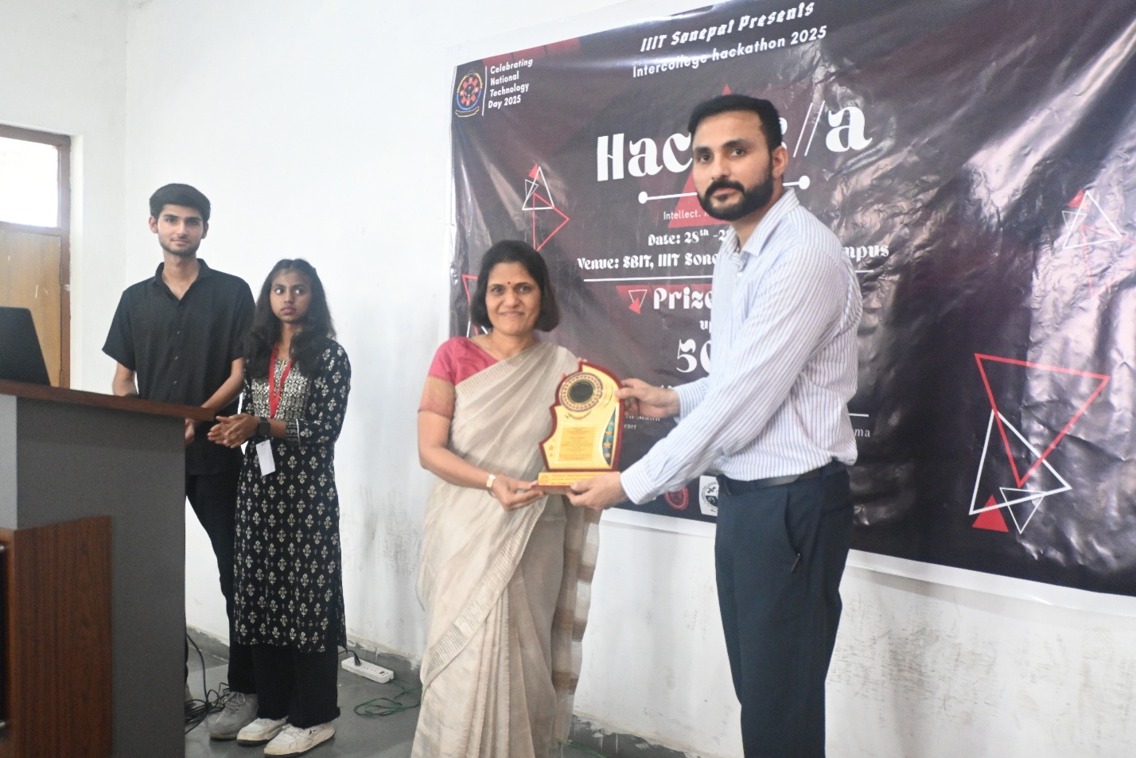
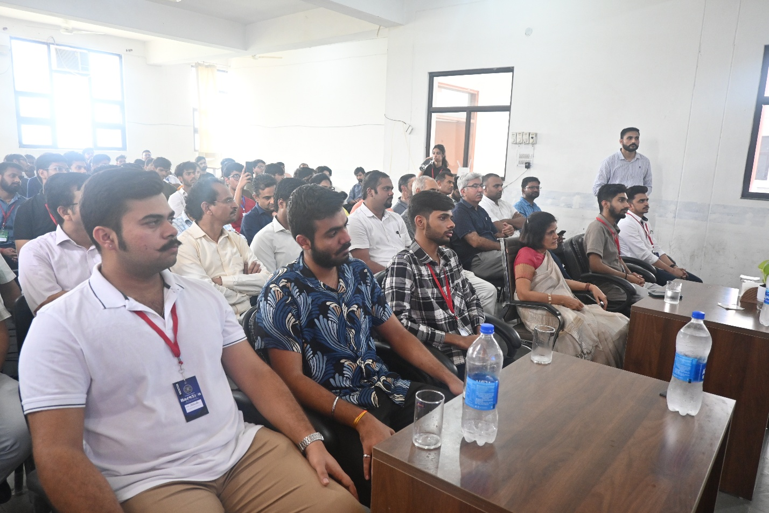
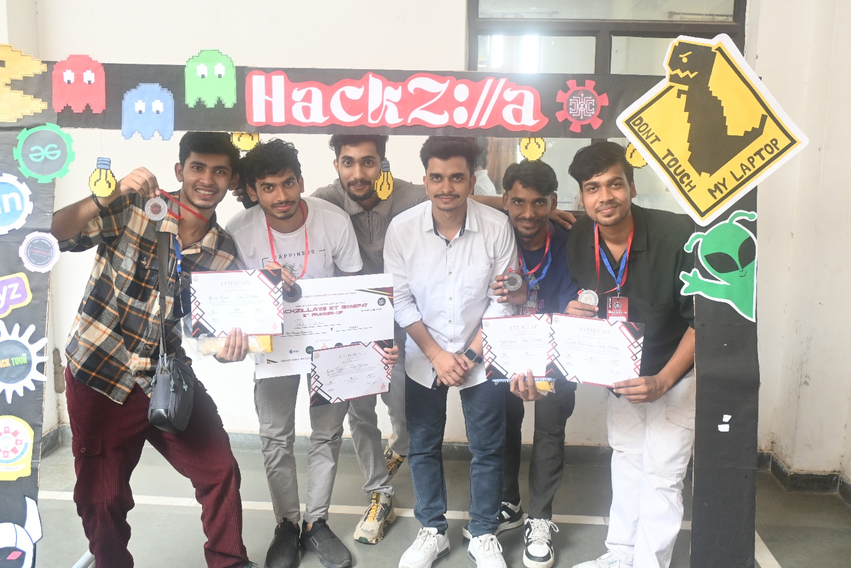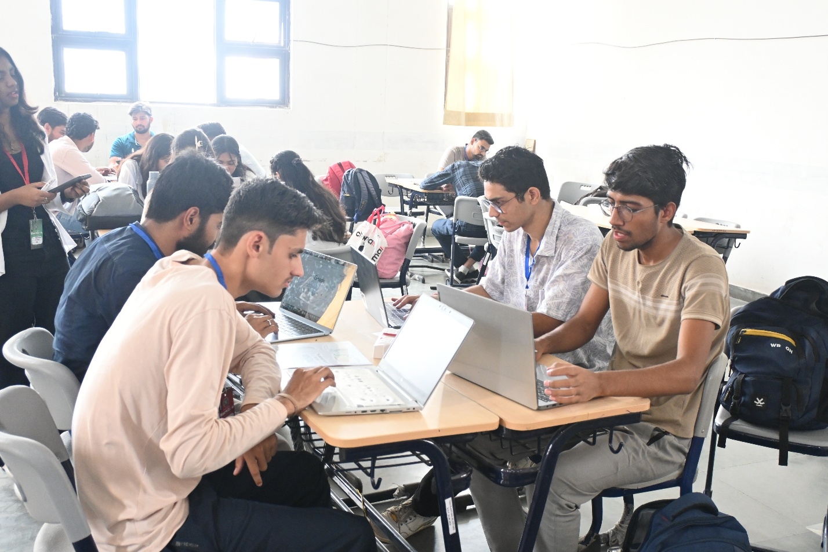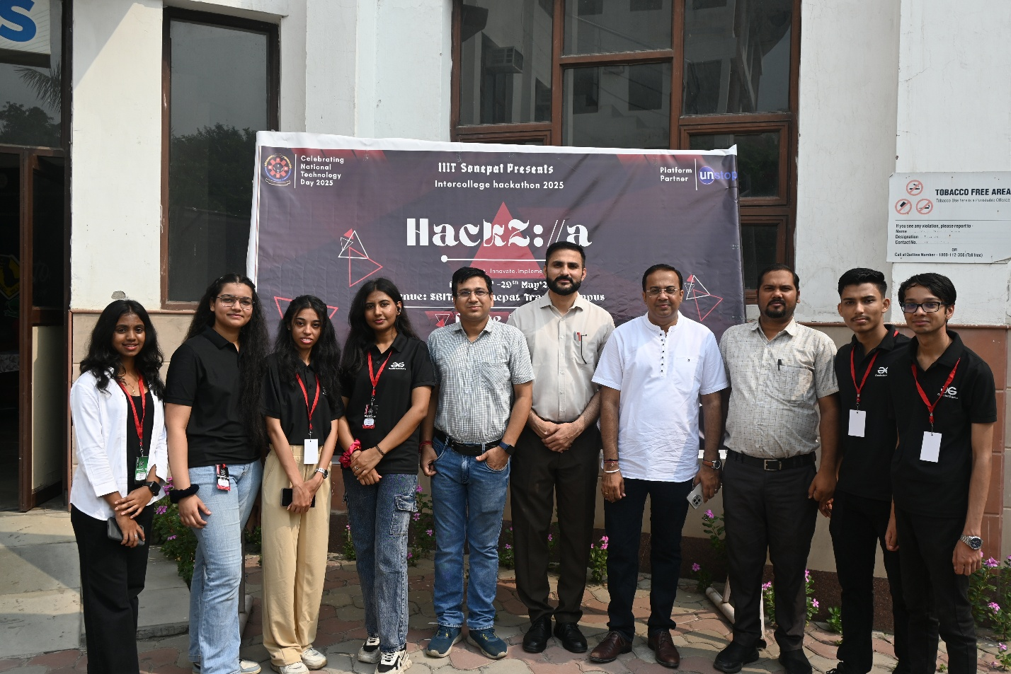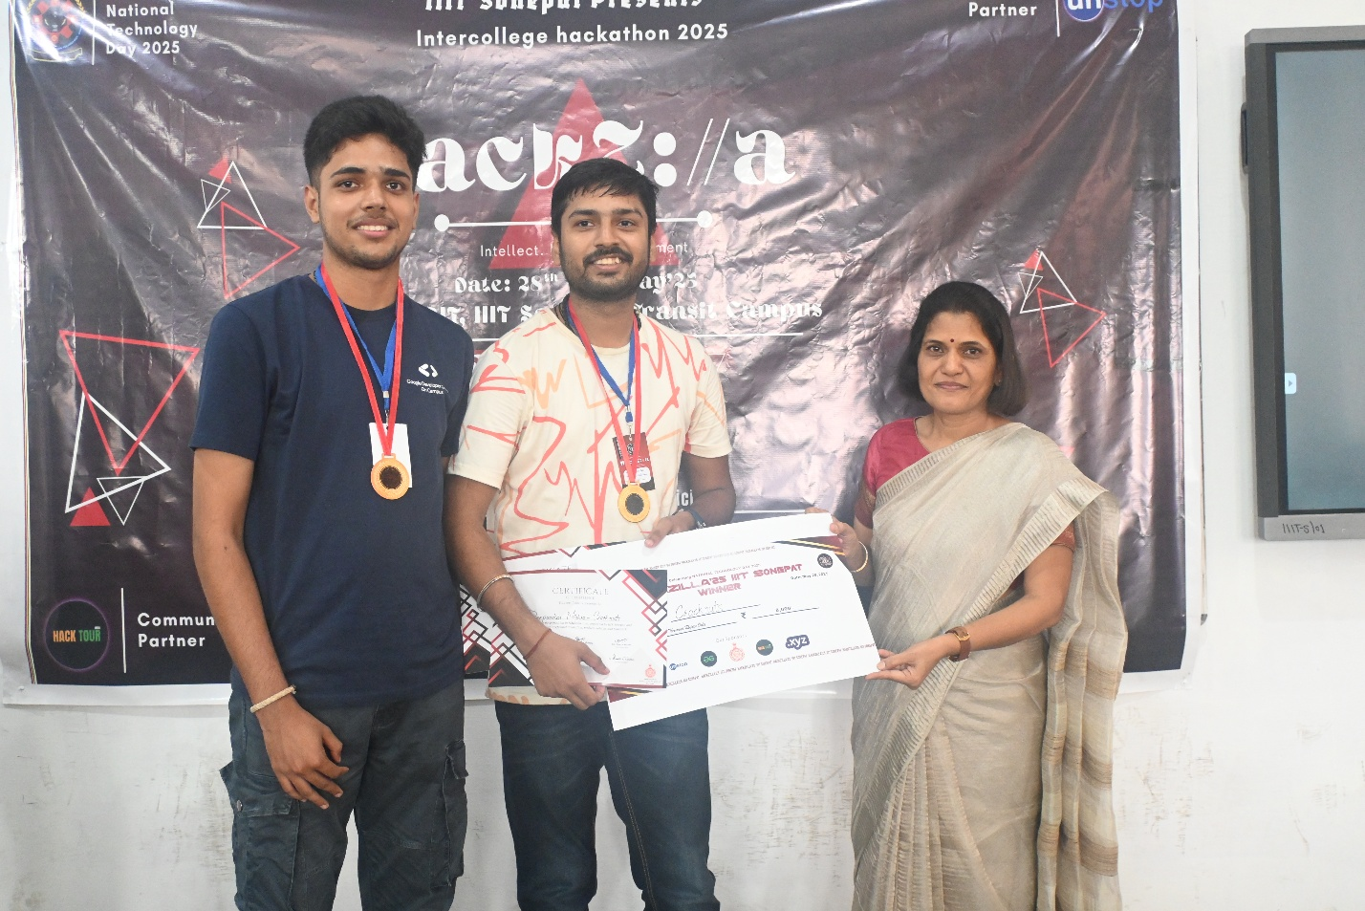

%%%%%%%%%%%%%%%%%NCC Initial Meeting pics%%%%%%%%%%%%%%%

